**Assignment No 5**

**NAME: Vishal Shashikant Salvi UID: 2019230069**

**CLASS: TE COMPS SUB: IOP**

**Title:**

**1. Compare any two organizations (2 marks)**

a. One who has not been able to implement Organizational development/change effectively in the changing environment resulting losing its edge in the market.

b. Other which has been able to implement Organizational development/change effectively with the changing times and is successful and maintaining competitive edge in the todays changing dynamics

**Organizations: (BSNL, Reliance Jio)**

**1)BSNL**

BSNL is an Indian [government enterprise](https://en.wikipedia.org/wiki/Government_of_India) and a [telecommunications service provider](https://en.wikipedia.org/wiki/Telecommunications_service_provider) headquartered in [New Delhi](https://en.wikipedia.org/wiki/New_Delhi), India. It is under the [ownership](https://en.wikipedia.org/wiki/Ownership) of [Department of Telecommunications](https://en.wikipedia.org/wiki/Department_of_Telecommunications), [Ministry of Communications](https://en.wikipedia.org/wiki/Ministry_of_Communications_(India)), [Government of India](https://en.wikipedia.org/wiki/Government_of_India). It was incorporated on 1st October 2000 by the [Government of India](https://en.wikipedia.org/wiki/Government_of_India).BSNL has taken several measures to reduce its debt, but still, it has failed to make profits. The state-run telecom operator BSNL has saved Rs. 10,000 crores annually as it has reduced its expenditure to Rs. 24,687 crores from Rs. 34,400 crores. The company has managed to save money due to its Voluntary Retirement Scheme (VRS) scheme under the revival package.

After saving Rs. 10, 000 crores, the parliamentary committee on IT said that telecom operator might not be profitable before 2023-24. BSNL has stated that it expects to be profitable from 2023-24 onwards, subject to a full realization of the revenue and cash flow from services as well as monetization of land assets as envisaged at the stage of processing of the revival package.

**BSNL not offering proper 4G services:**

The report also asks the Department of Telecommunication that why BSNL and MTNL have not given a 4G spectrum yet despite BSNL has floated the tender several times. Notably, the tender has been rejected as it has been asked to use domestic vendors. Apart from the 4G services, the Government approved the revival package of both BSNL and MTNL in 2019. The revival package includes a VRS scheme, 4G spectrum, merger of both public sector undertakings, and monetization of assets (including both core and non).

Notably, 92,956 employees of the telecom operators have opted for the VRS scheme. It is also expected that the merger of both telecom operators will help BSNL increase its presence in the country. Besides, a group of ministers said that BSNL will be given a 4G spectrum for offering services in Delhi and Mumbai.

Furthermore, the report said that 4G services will increase the revenue of the telecom operator.

**Why BSNL Losing Market Share?**  
All private telecom operators have already gained market share in 4G services and now they are looking at a 5G network. In fact, both Reliance Jio and Airtel have already started testing 5G services in the country. However, 5G is still far away, so even if BSNL gets a proper 4G spectrum in the next two or three months, there are chances that it will survive in the industry.

**2)Reliance Jio**

Mukesh Ambani led Reliance Jio launched its services on September 5, 2016 and changed the dynamics of the industry completely. With triggering price war to low cost 4G handsets, Jio has given several alternatives to customers, creating a neck-to-neck competition in the industry. Since its entry in the telecom sector Jio has been creating records and now another report by the Institute of Competitiveness has claimed that Jio’s launch in India has helped the country in saving around Rs60000 crore annually. The report also claimed that within 6 months Reliance Jio has made India the highest consumer of mobile data in the world. According to the report Jio will help expand India’s per capita GDP by about 5.65%, keeping other things in the economy constant.

**Developments in the Telecom Sector After Jio’s Entry**

1. **Ultra-Cheap Data-** Before the entry of Jio, data was very expensive, and consumers had to shell out huge amounts for 1 GB of data. Jio’s launch offer offered free data to consumers at high speed and even after it launched chargeable plans the tariff was very low and so other operators had to eventually follow and bring out new plans.
2. **Free Voice Calls-** Voice calls were a major income generator before Jio, but became free when it launched its services. Jio claims that its network presently carries 250 crore minutes a day of calls.
3. **Increased consumption of online content-** India saw an exponential rise in the consumption of online content with availability of free data. Jio claims that India’s consumption went from 20 crore GB data to 120 crore Gb in 6 months after it launched its services.
4. **Proliferation of 4G smartphones-** The market for 4G smartphones exploded after Jio launched its services as everyone has access to the company’s 4G network for free.
5. **A record in user acquisition-** Jio claimed that its telecom network had garnered 100 million users in less than 6 months of operations. It also said that this growth was faster that even what Facebook and WhatsApp recorded.
6. **Improved broadband Internet Availability**-TRAI defines broadband speeds as anything above 512kbps or above. With free internet millions of people got access to high speed 4G services and Jio became the country’s biggest provider of broadband internet.

**2. Design a Brochure describing a structure of organization using any one of the organization theories we have discussed in the chapter (3 marks)**

**Sociotechnical Systems Theory :(Reliance Jio Organization)**

Diagram Link which is design on creately platform:

<https://app.creately.com/diagram/vMgu1cYdlQv/edit>

Jio Platforms has raised a whopping USD 13.7 billion from global investors in less than eight weeks, a feat probably no other seven-month-old company has ever achieved anywhere in the world.

India’s largest company by market capitalization incorporated Jio Platforms on November 15 last year. And with that, it set in motion a plan to unlock the value of its digital assets, with Reliance Jio Info comm, its telecom venture, at the center.

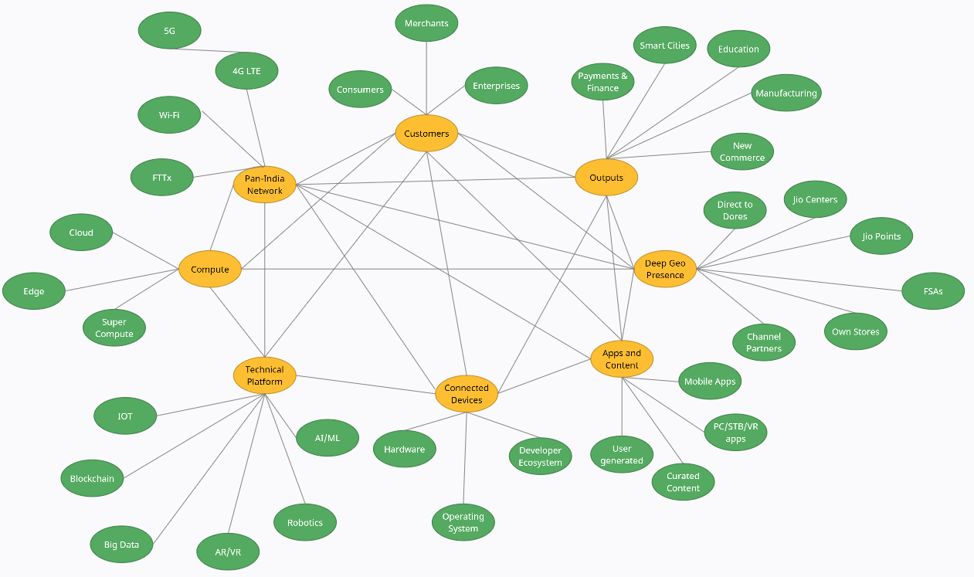

**Fig. Sociotechnical System theory structure on Reliance Jio**

**Digital Services**

1. Jio achieved milestone of US$ 10 billion annualized revenue run-rate
2. Strong Revenue and EBITDA growth led by subscriber additions across segments and ARPU uplift
3. ARPU increases to ₹ 151 (vs. ₹ 145 in 2Q FY21) with increased customer engagement
4. Strong momentum in customer additions – gross addition robust at 25.1 million, net addition at 5.2 million
5. Total customer base at 410.8 million as of December 2020
6. FTTH business scaling up rapidly with services being offered extensively across the country

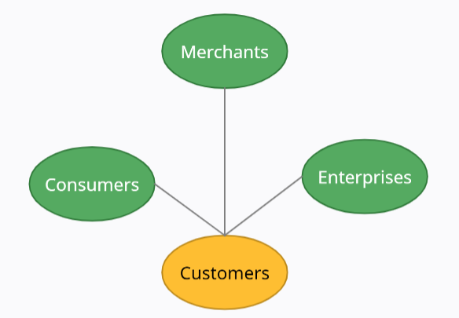

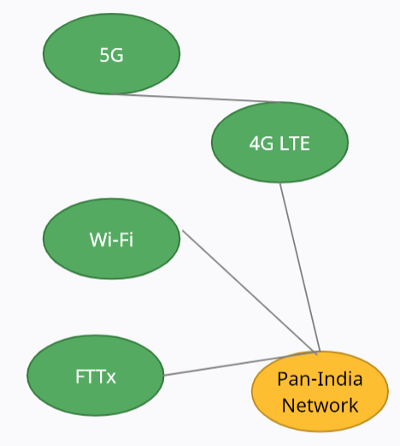

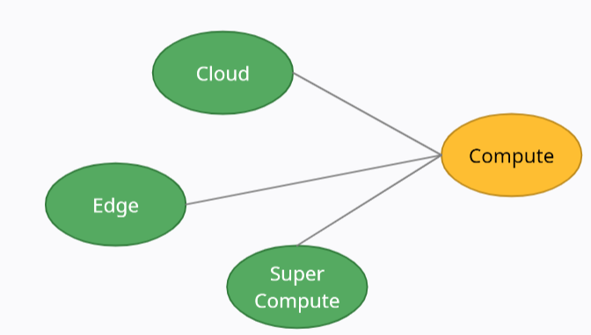

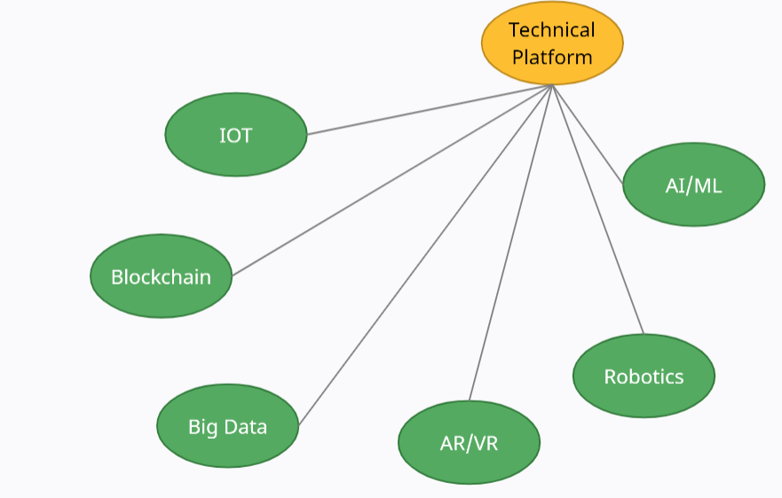

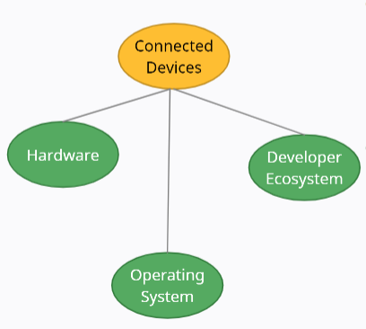

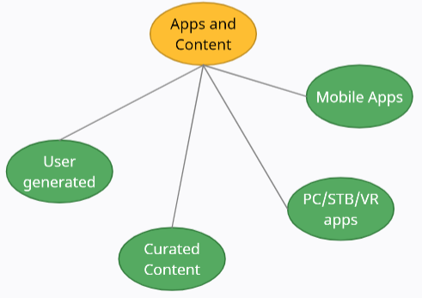

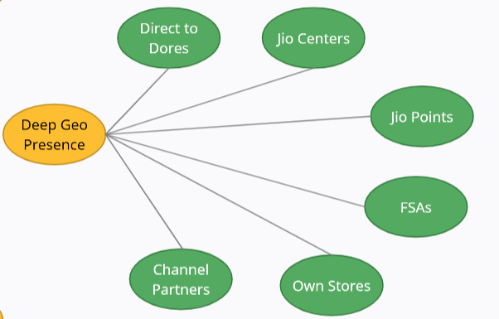

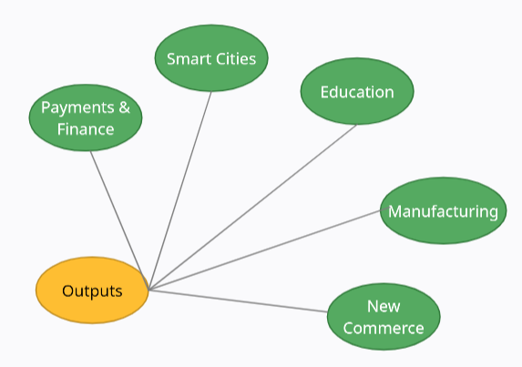

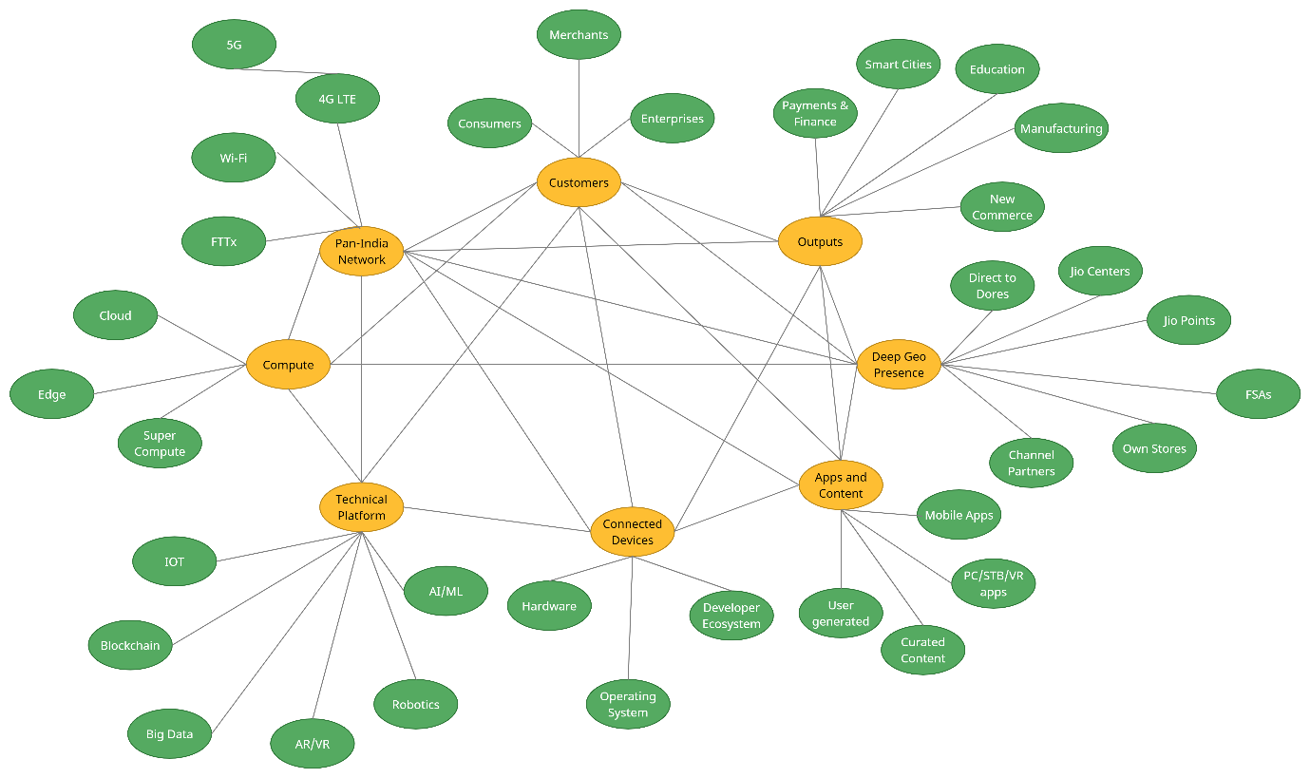

**Jio's 5G service will be a testimony to the vision of AtmaNirbhar Bharat:**

1. Indigenously developed 5G Radio, completing the entire end-to-end Jio 5G technology.
2. 5G Radio integrated with Jio’s 5G Core Network and 5G Smartphones to achieve throughputs > 1 Gbps.
3. gNodeB Small Cell is under manufacturing for a largescale field trial with test customers.
4. In-house Massive MIMO and indoor 5G small cell under advanced stages of development. RF capacity and coverage planning underway based on 4G data traffic profile.

**Jio Connecting Everyone Everywhere:**

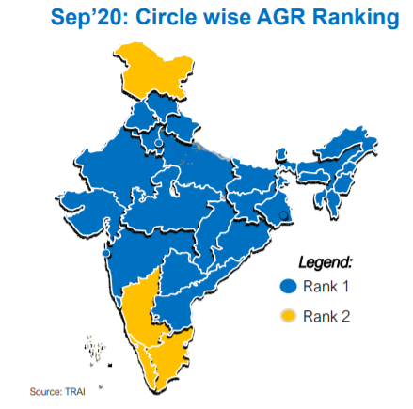

1. Market leadership in 18 out of 22 circles and overall AGR share of ~45% as of

Sep-20

1. Close 2nd in TN and J&K
2. Wider reach with 4G LTE network and differentiated sales & distribution approach drives customer connect
3. Attractive value proposition with end-to-end solution for all customer segments
4. Carrying one of the world’s highest data traffic with sustained network performance

**Jio Extending the Market Reach:**

**Virtual Assistant**

1. Available in 6 Languages: English, Hindi, Gujarati, Marathi Tamil, Telugu
2. Upcoming Languages: Kannada & Punjabi
3. Conversational Skills: Enhanced NLU to move from Command mode to conversational Mode
4. Speaker Recognition

**Recommendations**

1. Based on Market and Promotional Trends
2. User Analytics based recommendations
3. Based on Day part Trending

**Jio Home App:**

1. Soft TV Remote,
2. Soft Gaming Controller: Game Customized Console
3. My Media – Customer’s Personal Cloud on TV

**Profiles in STB**

1. User selected Profile creation
2. Content permissions for profiles (Parental Control)
3. Profile specific Recommendations
4. WatchList / Reminders: App agnostic listing and reminder setup

**Jio Smart Monitoring Solution**

1. Secure Home And Office with Indoor & Outdoor Cameras
2. Secured streaming and Cloud storage in India
3. Two Way Talk
4. Live/Smart Remote Monitoring
5. Legacy Agnostic (Supports Analog also)

**Jio Smart living Offerings**

1. Complete Home Automation Solution Catalogue including Safety, Security & Convenience Sensors
2. Targeted for Real Estate Developers
3. Multiple Project handovers scheduled through CY2021

**Jio Smart Living Platform**

1. White labeled App, IoT Module, Cloud
2. Enable Indian Appliance & Lighting ecosystem partners to offer smart products